Marla Foss, Anna Gesinger, Becky Hiltz, Randie Swanson
MathK-2
Probability
Standards Addressed:
Understand and apply basic concepts of probability
Launch:
Lets pretend we are walking up to a huge gumball machine. You see red, yellow, orange, green and purple gumballs. You have an equal chance to get each color. Who would want a red one, raise your hand, hands down. Yellow one, raise your hand, hands down. Orange one, raise your hand, hands down. Green one, raise your hand, hands down. Purple one, raise your hand, hands down. Now for all of you that wanted a red one, do you think that when you put your quarter in and turn the handle a red one will come out?
Class project, if we were to spin this 20 times, how many times do you think that it will land on each color?
Explore:
Open http://nlvm.usu.edu/en/nav/category_g_1_t_5.html
Click on Spinner 20 times, have students record results on a piece of paper, using tally marks. (You can let each student click on it or find a smart board application if possible)
Red, Yellow, Purple, Orange, Green; you can change the number of colors available and the percentage of the circle.
Summarize:
Have the students create a bar graph to show the results.
Apply:
At home the students take a paperclip, string, pencil and show a parent how to spin and record data.

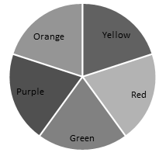
 | Red | Yellow | Orange | Green | Purple
15
14
13
12
11
10
9
8
7
6
5
4
3
2
1

